

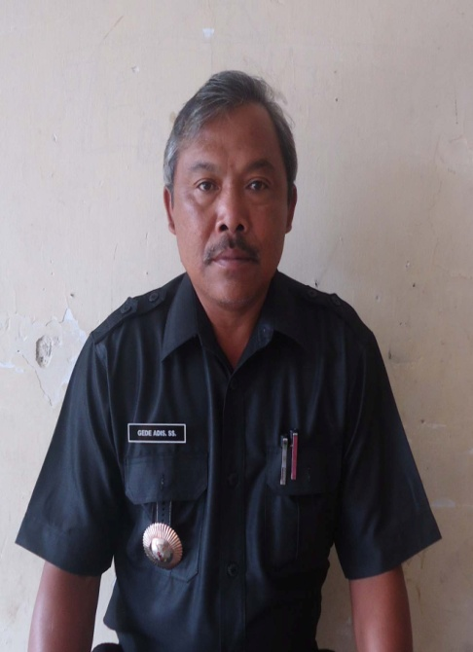



1. **REALISASI PENDAPATAN**

|  |  |  |  |
| --- | --- | --- | --- |
| 1. | PAD | Rp 32.272.814,77 | 1,71% |
| 2. | DANA DESA | Rp 790.578.196,98 | 41,81% |
| 3. | BHP | Rp 96.254.085,60 | 5,09% |
| 4. | BHR | Rp 13.750.583,66 | 0,73% |
| 5. | ADD | Rp 591.132.746,56 | 31,26% |
| 6. | BKK | Rp 350.000.000,00 | 18,51% |
| 7. | LAIN-LAIN | Rp 17.000.000,00 | 0,90% |
|  |  |  |  |
| **JUMLAH** | | **Rp 1.890.988.427,57** | |

1. **REALISASI BELANJA**

|  |  |  |  |
| --- | --- | --- | --- |
| 1. | PEMERINTAHAN | Rp 544.374.030,00 | 31,71% |
| 2. | PEMBANGUNAN | Rp 972.028.865,00 | 56,61% |
| 3. | KEMASYARAKATAN | Rp 131.898.000,00 | 7,68% |
| 4. | PEMBERDAYAAN | Rp 68.686.000,00 | 4,00% |
| 5. | TAK TERDUGA | Rp - | 0,00% |
|  |  |  |  |
|  | **JUMLAH** | **Rp 1.716.986.895,00** | |

**REALISASI APB DESA UMEJERO TAHUN ANGGARAN 2017**

**ANGGARAN PENDAPATAN DAN BELANJA DESA TAHUN ANGGARAN 2018**

1. **PEMBIAYAAN**

|  |  |  |
| --- | --- | --- |
| 1. | PENERIMAAN PEMBIAYAAN | Rp 339.338.775,00 |
| 2. | PENGELUARAN PEMBIAYAAN | Rp - |
| **JUMLAH** | | **Rp 339.338.775,00** |

1. **ANGGARAN PENDAPATAN**

|  |  |  |  |
| --- | --- | --- | --- |
| 1. | PAD | Rp 21.000.000,00 | 1,71% |
| 2. | DANA DESA | Rp 790.578.196,98 | 41,81% |
| 3. | BHP | Rp 101.595.252,31 | 5,09% |
| 4. | BHR | Rp 14.428.797,99 | 0,73% |
| 5. | ADD | Rp 588.501.881,03 | 31,26% |
| 6. | BKK | Rp 1.046.767.400,00 | 18,51% |
| 7. | LAIN-LAIN | Rp 4.350.000,00 | 0,90% |
| **JUMLAH** | | **Rp 2.567.221.528,31** | |

1. **ANGGARAN BELANJA**

|  |  |  |  |  |
| --- | --- | --- | --- | --- |
| 1. | PEMERINTAHAN | Rp 1.083.123.931,33 | 31,71% |  |
| 2. | PEMBANGUNAN | Rp 1.524.911.175,00 | 56,61% |  |
| 3. | KEMASYARAKATAN | Rp 188.092.000,00 | 7,68% |  |
| 4. | PEMBERDAYAAN | Rp 105.583.196,98 | 4,00% |  |
| 5. | TAK TERDUGA | Rp 4.850.000,00 | 0,00% |  |
|  | **JUMLAH** | **Rp 2.906.560.303,31** | |  |